

PABNA UNIVERSITY OF SCIENCE AND TECHNOLOGY
Department of Information and Communication Engineering (ICE)
LAB REPORT
Course Code: ICE-2204
Course Title: Signals and Systems Sessional
Submitted by:  Sazia Afrin Labonna  Roll: 210621  Session: 2020-21  2nd Year 2nd Semester  Department of ICE, PUST | Submitted to:  Dr. Md. Imran Hossain  Associate Professor  Department of Information and Communication Engineering(ICE),  Pabna University of Science and Technology, Pabna.

Sl. | Problem Statement
1. | Explain and implementation of Signal sequence- Impulse Signal, Step Signal, Ramp Signal
2. | Expain and Emplementation of Signal Operation- Adding, Shifting,Folding, Multiplication
3. | Explain and implementation of  convolution operation of sequences
4. | Explain and implementation of Auto-correlation and Cross-correlation of Discrete-time sequences
5. | Explain and implement PPG Signal- Filtering,Feature extraction, Peak detection
6. | Explain and implementn Fourier Transform
7. | Explain and implement DFT and IDFT

Index

Experiment No:01
Experiment Name: Explain and implementation of Signal sequence- Impulse Signal, Step Signal, Ramp Signal.
Theory:
1. Impulse Signal
An impulse signal is a very short-duration signal that is characterized by a spike or discontinuity at a specific time point, typically occurring at t=0. It is commonly represented as a Dirac delta function (δ(t)).
Mathematical Representation: δ(t)

2. Step Signal
A step signal (also called a Heaviside function) is a signal that changes abruptly from one value (usually 0) to another value (usually 1) at a specific time, typically at t=0.
- Mathematical Representation:
u(t)={ ₁⁰ _{for >=0}^{for t<0}

3. Ramp Signal
A ramp signal is a signal that increases (or decreases) linearly over time. It typically starts from 0 and increases (or decreases) without bound at a constant rate.
- Mathematical Representation: r(t)=At, where A is the slope (rate of change) of the ramp.

Source Code in MATLAB:
% Define time vector
t = -10:0.1:10; % Time from -10 to 10 with step size 0.1

% Define the signals
impulse = @(t) (t == 0); % Impulse signal (Dirac delta approximation)
step = @(t) double(t >= 0); % Unit step function
ramp = @(t) t .* (t >= 0); % Ramp signal

% Generate signals
impulse_signal = impulse(t);
step_signal = step(t);
ramp_signal = ramp(t);

% Plot the signals
subplot(3, 1, 1);
plot(t, impulse_signal, 'LineWidth', 2);
title('Impulse Signal');
xlabel('Time');
ylabel('Amplitude');
grid on;

subplot(3, 1, 2);
plot(t, step_signal, 'LineWidth', 2);
title('Step Signal');
xlabel('Time');
ylabel('Amplitude');
grid on;

subplot(3, 1, 3);
plot(t, ramp_signal, 'LineWidth', 2);
title('Ramp Signal');
xlabel('Time');
ylabel('Amplitude');
grid on;

Input & Output:
Purpose: Here are the purposes of each signal sequence in short:
- Impulse Signal: Used to analyze a system's response (impulse response), helping characterize system behavior.
- Step Signal: Used to study a system's steady-state and transient response (step response) to a sudden change in input.
- Ramp Signal: Used to evaluate a system's response to a gradually increasing input (ramp response).

Experiment No:02
Experiment Name: Expain and Emplementation of Signal Operation- Adding, Shifting,Folding, Multiplication
Theory:

1. Addition of Signals
Signal addition involves summing two or more signals at each corresponding point in time. This operation is commonly used when signals are combined or when different inputs are applied to a system simultaneously.
- Mathematical Representation:
y(t)=x₁(t)+x₂(t)
where x₁(t) and x₂(t)are two signals, and y(t) is the resultant signal

2. Shifting of Signals (Time Shifting)
Shifting a signal involves shifting the entire signal either to the left (time delay) or to the right (time advance) along the time axis. This operation is useful for time-domain analysis of signals and systems.
- Mathematical Representation:
  - Right Shift (Delay): y(t)=x(t−t₀)
  - Left Shift (Advance): y(t)=x(t+t₀)​ is the amount of shift

3. Folding of Signals (Time Reversal or Reflection)
Folding (or time reversal) involves flipping the signal about the vertical axis (time axis). Essentially, folding a signal results in a mirror image of the original signal along the time axis.
- Mathematical Representation:
y(t)=x(−t)
where x(t) is the original signal and y(t) is the folded (reversed) signal.

Source Code MATLAB:
% Define time vector
t = -10:0.1:10; % Time from -10 to 10 with step size 0.1

% Define signals
u = @(t) double(t >= 0); % Unit step function
delta = @(t) (t == 0); % Impulse signal (Dirac delta approximation)

% Example 1: Adding Signals
signal1 = u(t); % Unit step signal
signal2 = delta(t); % Impulse signal
added_signal = signal1 + signal2;

% Plot the result of adding signals
subplot(2,2,1);
plot(t, added_signal, 'LineWidth', 2);
title('Added Signal (Step + Impulse)');
xlabel('Time');
ylabel('Amplitude');
grid on;

% Example 2: Shifting Signals
shift_amount = 3; % Shift by 3 units to the right
shifted_signal = u(t - shift_amount); % Shift the step signal

% Plot the result of shifting signals
subplot(2,2,2);
plot(t, shifted_signal, 'LineWidth', 2);
title('Shifted Signal (Step Shifted by 3)');
xlabel('Time');
ylabel('Amplitude');
grid on;

% Example 3: Folding Signals
folded_signal = fliplr(u(t)); % Folding the step signal (time reversal)

% Plot the result of folding signals
subplot(2,2,3);
plot(t, folded_signal, 'LineWidth', 2);
title('Folded Signal (Time Reversed Step)');
xlabel('Time');
ylabel('Amplitude');
grid on;

% Example 4: Multiplying Signals
signal3 = 2 * u(t); % Scaled unit step signal
multiplied_signal = signal1 .* signal3; % Element-wise multiplication

% Plot the result of multiplying signals
subplot(2,2,4);
plot(t, multiplied_signal, 'LineWidth', 2);
title('Multiplied Signal (Step * Scaled Step)');
xlabel('Time');
ylabel('Amplitude');
grid on;

Input & Output:
Purpose: Here are the purposes of each signal operation in short:
- Adding Signals: Used to combine two or more signals to observe the collective effect on a system.
- Shifting Signals: Used to modify the timing of a signal (delay or advance), helping in time alignment or system response analysis.
- Folding Signals: Used to invert or reflect a signal about a specific point (usually time zero), helpful in analyzing symmetrical systems.
- Multiplying Signals: Used to modulate or scale signals, often used in systems involving filtering or amplitude modulation.

Experiment No:03
Experiment Name:Explain and implementation of
convolution operation of sequences.
Theory:
Convolution is a mathematical operation used to determine the output (response) of a linear time-invariant (LTI) system given an input signal and the system's impulse response. It essentially combines the two signals by shifting, multiplying, and summing them.
For discrete-time sequences x[n] and h[n], the convolution y[n] is defined as:
$y\left[n\right]=\left(x*h\right)\left[n\right]$=$\sum_{k=-∞}^{∞}{x[k].h[n-k]}$

Source Code in MATLAB:
% Define the sequences x[n] and h[n]
x = [1, 2, 3, 4]; % Input signal
h = [1, -1, 2]; % Impulse response

% Perform the convolution operation
y = conv(x, h); % Convolution of x and h

% Plot the input sequences and their convolution result
figure;

% Plot x[n]
subplot(3, 1, 1);
stem(x, 'filled');
title('Input Signal x[n]');
xlabel('n');
ylabel('x[n]');
grid on;

% Plot h[n]
subplot(3, 1, 2);
stem(h, 'filled');
title('Impulse Response h[n]');
xlabel('n');
ylabel('h[n]');
grid on;

% Plot the convolution result y[n]
subplot(3, 1, 3);
stem(y, 'filled');
title('Convolution Result y[n] = x[n] * h[n]');
xlabel('n');
ylabel('y[n]');
grid on;

Input & Output:
Purpose: The convolution operation is used to determine the output (response) of a linear time-invariant (LTI) system when given an input signal and the system's impulse response. It models how the system reacts to different inputs over time

Experiment No:04
Experiment Name:Explain and implementation of Auto-correlation and Cross-correlation of Discrete-time sequences.
Theory:
Correlation is a fundamental operation in signal processing used to measure the similarity between signals. The two main types of correlation are:
- Autocorrelation: Measures how a signal correlates with a delayed version of itself. It helps in analyzing periodicity and detecting patterns in signals.
Formula: $R_{x}(k) = \sum_{n}{x(n) x(n - k)}$
where x(n) is the signal, and ‘k’ is the lag.
- Cross-Correlation: Measures the similarity between two different signals as a function of time shift. It is widely used in time-delay estimation and pattern recognition.
Formula: $R_{xy}(k) = \sum_{n}{x(n) y(n - k)}$
where x(n) and y(n) are two different signals, and ‘k’ is the lag.

Source Code in MATLAB:
% Define the sequences x[n] and y[n]
x = [1, 2, 3, 4]; % First sequence
y = [4, 3, 2, 1]; % Second sequence

% Calculate the Auto-correlation of x[n]
auto_corr_x = xcorr(x, 'unbiased'); % Auto-correlation of x[n]

% Calculate the Cross-correlation between x[n] and y[n]
cross_corr_xy = xcorr(x, y, 'unbiased'); % Cross-correlation between x[n] and y[n]

% Plot the Auto-correlation of x[n]
figure;
subplot(2, 1, 1);
stem(-length(x)+1:length(x)-1, auto_corr_x, 'filled');
title('Auto-correlation of x[n]');
xlabel('Lag (m)');
ylabel('Auto-correlation');
grid on;

% Plot the Cross-correlation between x[n] and y[n]
subplot(2, 1, 2);
stem(-length(x)+1:length(x)-1, cross_corr_xy, 'filled');
title('Cross-correlation between x[n] and y[n]');
xlabel('Lag (m)');
ylabel('Cross-correlation');
grid on;

Input & Output:

Purpose: Purpose of Auto-correlation and Cross-correlation:
- Auto-correlation:
  - Measures the similarity of a signal with a delayed version of itself.
  - Used to analyze patterns, periodicity, and repetitive features within a signal.
- Cross-correlation:
  - Measures the similarity between two different signals as one is shifted over time.
  - Used to find similarities or detect time delays between two signals.

Experiment No:05
Experiment Name:Explain and implement PPG Signal- Filtering,Feature extraction, Peak detection.
Theory:
- Filtering:
  - Purpose: Removes noise and unwanted components from the PPG signal, such as motion artifacts and power-line interference.
  - Method: Common filtering techniques include low-pass filters (to remove high-frequency noise) and band-pass filters (to isolate the frequency range corresponding to the heart rate).
- Feature Extraction:
  - Purpose: Extracts meaningful characteristics from the PPG signal, like heart rate, respiration rate, and pulse amplitude.
  - Method: Features such as peak-to-peak intervals, pulse amplitude, and frequency-domain features (from Fourier Transform or wavelet transform) are extracted for physiological analysis.
- Peak Detection:
  - Purpose: Identifies key points (peaks) in the PPG signal, usually the systolic peaks (heartbeats) to determine heart rate or other vital signs.
  - Method: Peak detection algorithms, such as thresholding, derivative-based methods, or wavelet transforms, are used to find the locations of peaks and calculate intervals (e.g., RR intervals for heart rate).
These operations are essential for accurately interpreting PPG signals in health monitoring systems.

Source Code in Python:
import numpy as np
import matplotlib.pyplot as plt

# Simulating a PPG signal (replace with actual data)
fs = 100 # Sampling rate (Hz)
t = np.linspace(0, 10, fs * 10) # 10 seconds of data
ppg_signal = 0.6 * np.sin(2 * np.pi * 1.2 * t) + np.random.normal(0, 0.05, len(t))

# Plotting the raw PPG signal
plt.plot(t, ppg_signal)
plt.title("Raw PPG Signal")
plt.xlabel("Time (seconds)")
plt.ylabel("Amplitude")
plt.show()
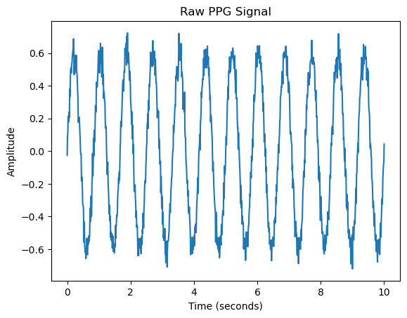
from scipy.signal import butter, filtfilt

# Bandpass filter design (0.5 to 5 Hz for heart rate detection)
def bandpass_filter(signal, lowcut, highcut, fs, order=4):
nyquist = 0.5 * fs
low = lowcut / nyquist
high = highcut / nyquist
b, a = butter(order, [low, high], btype='band')
return filtfilt(b, a, signal)

# Filtered PPG signal
filtered_ppg = bandpass_filter(ppg_signal, 0.5, 5, fs)
plt.plot(t, filtered_ppg)
plt.title("Filtered PPG Signal")
plt.xlabel("Time (seconds)")
plt.ylabel("Amplitude")
plt.show()
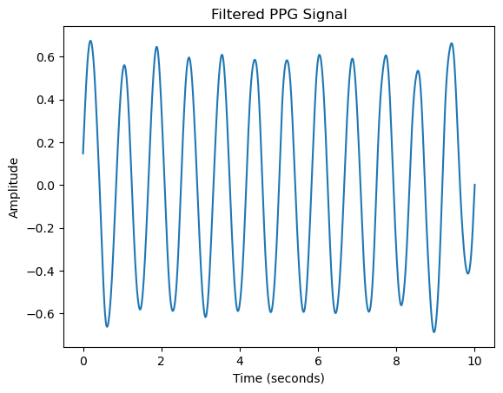
normalized_ppg = (filtered_ppg - np.min(filtered_ppg)) / (np.max(filtered_ppg) - np.min(filtered_ppg))
plt.plot(t, normalized_ppg)
plt.title("Normalized PPG Signal")
plt.xlabel("Time (seconds)")
plt.ylabel("Normalized Amplitude")
plt.show()
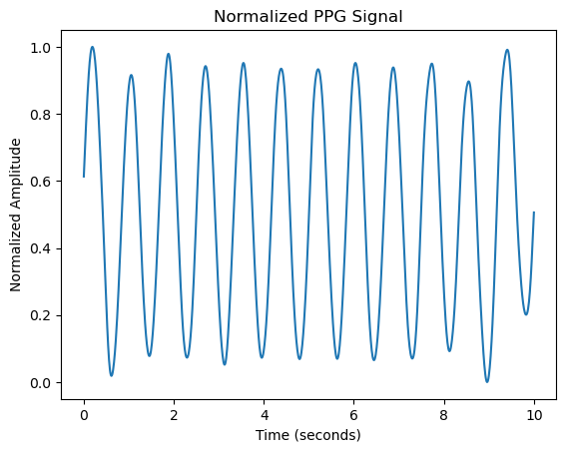

from scipy.signal import find_peaks

# Detect peaks in the PPG signal
peaks, _ = find_peaks(normalized_ppg, distance=fs*0.6) # Minimum distance of 0.6 seconds between peaks (for HR < 100 BPM)

# Calculate Heart Rate (BPM)
ibi = np.diff(peaks) / fs # Inter-beat interval in seconds
heart_rate = 60 / ibi # Convert to beats per minute (BPM)

# Plot the PPG signal with detected peaks
plt.plot(t, normalized_ppg)
plt.plot(t[peaks], normalized_ppg[peaks], "x")
plt.title("PPG Signal with Detected Peaks (Heartbeats)")
plt.xlabel("Time (seconds)")
plt.ylabel("Normalized Amplitude")
plt.show()

print("Heart Rate: ", np.mean(heart_rate), " BPM")
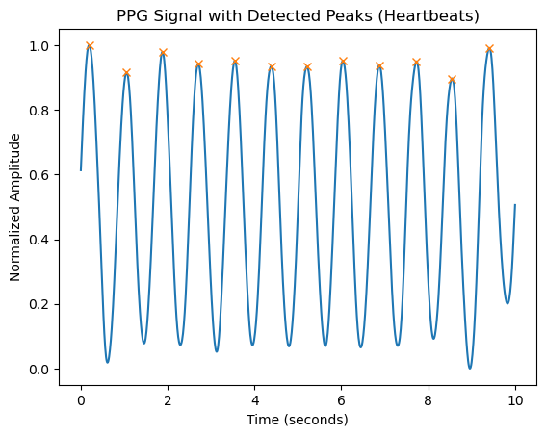
Heart Rate: 71.68175833415685 BPM
#Oxygen Saturation (SpO2) Calculation
# Assume red and infrared PPG signals (simulated)
red_ppg = 0.7 * np.sin(2 * np.pi * 1.2 * t) + np.random.normal(0, 0.05, len(t))
infrared_ppg = 0.6 * np.sin(2 * np.pi * 1.2 * t) + np.random.normal(0, 0.05, len(t))

# SpO2 estimation (simplified version)
ratio = np.mean(red_ppg) / np.mean(infrared_ppg)
SpO2 = 110 - 25 * ratio # Formula depends on device calibration

print("Estimated SpO2: ", SpO2, "%")
Estimated SpO2: 72.429133113864 %

import matplotlib.pyplot as plt

# Simulated heart rate and SpO2 data
time = np.arange(0, len(heart_rate)) # Time index for heart rate
SpO2_values = np.random.normal(95, 1, len(time)) # Simulated SpO2 values

# Plotting heart rate and SpO2
plt.subplot(2, 1, 1)
plt.plot(time, heart_rate, label='Heart Rate (BPM)')
plt.ylabel('BPM')
plt.title('Heart Rate and SpO2 Over Time')

plt.subplot(2, 1, 2)
plt.plot(time, SpO2_values, label='SpO2 (%)', color='red')
plt.ylabel('SpO2 (%)')
plt.xlabel('Time (seconds)')

plt.show()

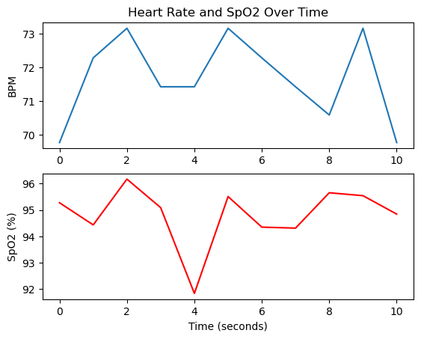

Purpose: Purpose of PPG Signal Operations:
- Filtering:
  - Removes noise and unwanted frequency components (e.g., motion artifacts or power line interference) from the PPG signal, ensuring accurate measurement of physiological parameters.
- Feature Extraction:
  - Extracts important characteristics from the PPG signal, such as heart rate, respiration rate, or pulse amplitude, to analyze the health status of an individual.
- Peak Detection:
  - Identifies the peaks (e.g., R-peaks in the pulse waveform), which are crucial for calculating heart rate and analyzing the timing of cardiac cycles.

Experiment No:06
Experiment Name: Explain and implementn Fourier Transform
Theory: The Fourier Transform is a mathematical operation that transforms a signal from the time domain into the frequency domain. It decomposes a signal into its constituent sinusoidal components (sine and cosine waves), allowing us to analyze the signal in terms of its frequencies.
- Mathematical Definition: For a continuous-time signal x(t), the Fourier Transform X(f) is given by:
$$X(f)=\int_{-∞}^{∞}{x(t).e^{-j2πft}}dt$$

Source Code:
% Define the parameters
fs = 1000; % Sampling frequency (1000 Hz)
T = 1/fs; % Sampling period
L = 1000; % Length of the signal (1000 samples)
t = (0:L-1) * T; % Time vector

% Generate a signal: a sum of two sine waves
f1 = 50; % Frequency of the first sine wave (50 Hz)
f2 = 150; % Frequency of the second sine wave (150 Hz)
signal = sin(2*pi*f1*t) + 0.5*sin(2*pi*f2*t); % Signal composed of two sine waves

% Perform the Fourier Transform using fft()
Y = fft(signal); % Compute the Fourier Transform of the signal

% Compute the two-sided spectrum (magnitude)
P2 = abs(Y/L); % Two-sided amplitude spectrum
P1 = P2(1:L/2+1); % Single-sided spectrum
P1(2:end-1) = 2*P1(2:end-1); % Correct the amplitude for the single-sided spectrum

% Frequency vector
f = fs*(0:(L/2))/L; % Frequency vector for the positive frequencies

% Plot the signal
figure;
subplot(2,1,1);
plot(t, signal, 'b');
title('Original Signal');
xlabel('Time (seconds)');
ylabel('Amplitude');
grid on;

% Plot the frequency spectrum
subplot(2,1,2);
plot(f, P1, 'r');
title('Frequency Spectrum');
xlabel('Frequency (Hz)');
ylabel('|P1(f)|');
grid on;

Input & Output:
Purpose: The Fourier Transform is used to convert a signal from the time domain to the frequency domain. Its purpose is to analyze the frequency components of a signal, helping to understand its spectral characteristics, filter design, signal processing, and system behavior.

Experiment No:07
Experiment Name:Explain and implement DFT and IDFT.
Theory:
The Discrete Fourier Transform (DFT) is the discrete-time counterpart of the Fourier Transform and is used to transform a discrete sequence of time-domain samples into the frequency domain. The Inverse Discrete Fourier Transform (IDFT) is used to convert the frequency-domain representation back into the time domain.

DFT Definition
For a given discrete sequence x[n], the Discrete Fourier Transform X[k] is defined as:
$$X[k]=\sum_{n=0}^{N-1}{x[n].e^{-j\frac{2π}{N}}}kn, k=0,1,2,....,N-1$$

IDFT Definition
The Inverse Discrete Fourier Transform (IDFT) allows us to recover the original time-domain sequence from its frequency-domain representation X[k]. It is defined as:
$x[n]=\frac{1}{N}\sum_{k=0}^{N-1}{x[k].}e^{j\frac{2π}{N}}kn$ , n=0,1,2,………,N-1

Source Code in MATLAB:
% Define the time-domain sequence (example)
x = [1, 1,1,1]; % Example sequence x[n]

% Length of the sequence
N = length(x);

% Compute DFT manually
X_dft = zeros(1, N); % Initialize DFT array
for k = 1:N
for n = 1:N
X_dft(k) = X_dft(k) + x(n) * exp(-1j * 2 * pi * (k-1) * (n-1) / N);
end
end

% Compute IDFT manually
x_idft = zeros(1, N); % Initialize IDFT array
for n = 1:N
for k = 1:N
x_idft(n) = x_idft(n) + (1/N) * X_dft(k) * exp(1j * 2 * pi * (k-1) * (n-1) / N);
end
end

% Plotting the sequences in 3 subplots
figure;

% Plot the original sequence x[n]
subplot(3,1,1);
stem(0:N-1, x, 'filled');
title('Original Sequence x[n]');
xlabel('n');
ylabel('x[n]');
grid on;

% Plot the magnitude of the DFT of x[n]
subplot(3,1,2);
stem(0:N-1, abs(X_dft), 'filled'); % Plot magnitude of X[k]
title('Magnitude of DFT |X[k]|');
xlabel('k');
ylabel('|X[k]|');
grid on;

% Plot the reconstructed sequence (from IDFT)
subplot(3,1,3);
stem(0:N-1, real(x_idft), 'filled'); % Real part of IDFT (should be close to x[n])
title('Reconstructed Sequence (IDFT)');
xlabel('n');
ylabel('x[n]');
grid on;

% Verify with MATLAB built-in functions
X_fft = fft(x); % Built-in FFT function
x_ifft = ifft(X_fft); % Built-in IFFT function

% Display and compare with manually computed DFT and IDFT
disp('DFT using fft():');
disp(X_fft);

disp('IDFT using ifft():');
disp(x_ifft);

Input & Output:

Purpose: Purpose of DFT and IDFT:
- DFT (Discrete Fourier Transform):
  - Converts a discrete-time signal from the time domain to the frequency domain. It helps analyze the frequency components of a signal and is widely used in signal processing, filtering, and spectral analysis.
- IDFT (Inverse Discrete Fourier Transform):
  - Converts a signal from the frequency domain back to the time domain. It is used to reconstruct the original signal after frequency-domain operations, such as filtering or compression.

